Ideation Phase
Empathize & Discover

Date | 17 February 2026
Team ID | LTVIP2026TMIDS66452
Project Name | ResolveNow: Your Platform for Online Complaints
Maximum Marks | 4 Marks

Empathy Map Canvas:
An empathy map is a simple, easy-to-digest visual that captures knowledge about a user’s behaviours and attitudes regarding the complaint process. It is a useful tool to help the ResolveNow team better understand their users, specifically the citizens reporting grievances and the agents managing them. Creating an effective solution requires understanding the true problem—such as the frustration of untracked complaints—and the person who is experiencing it. The exercise of creating the map helps participants consider things from the user’s perspective along with his or her goals of achieving a resolution and the challenges of navigating current administrative delays.
Example:

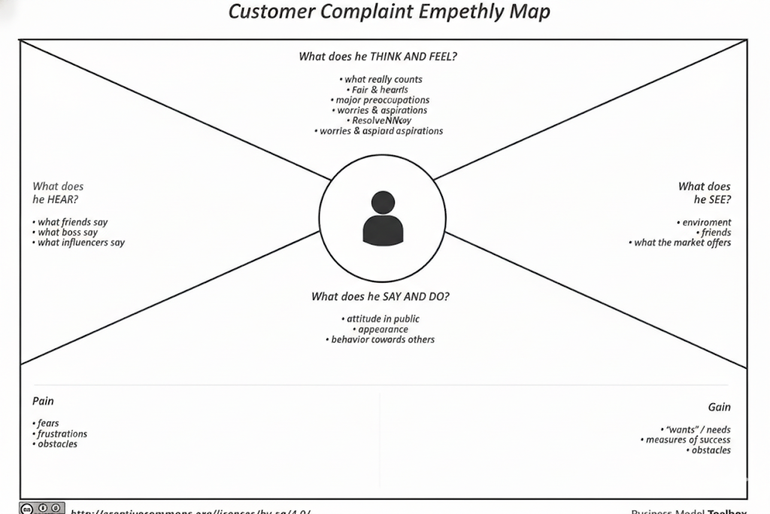

Example: Food Ordering & Delivery Application
